Thai Khong
6/25/26

Task 2: Secure Coding and Secure API Implementation

A1)
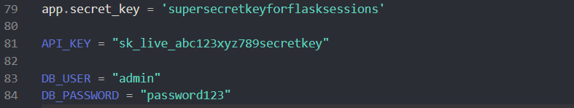
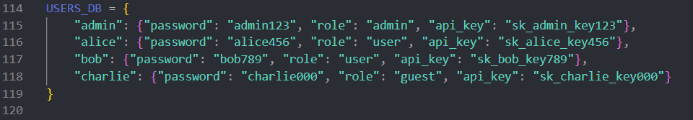
A2)
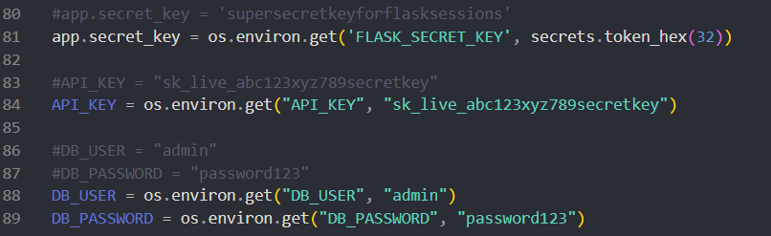
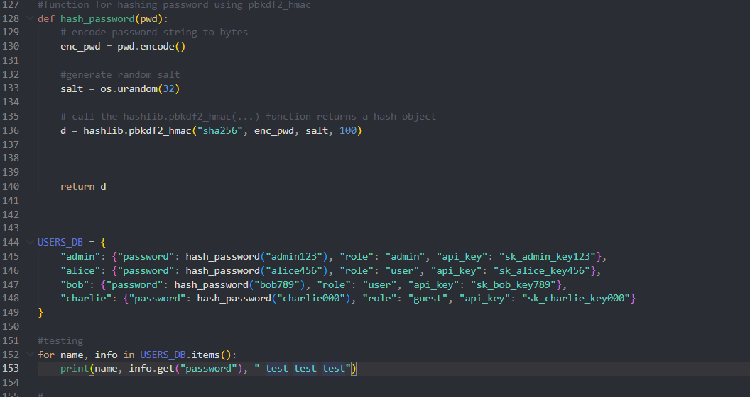
B)
B1)
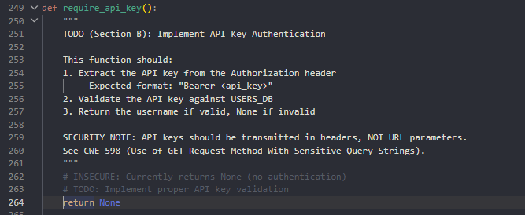
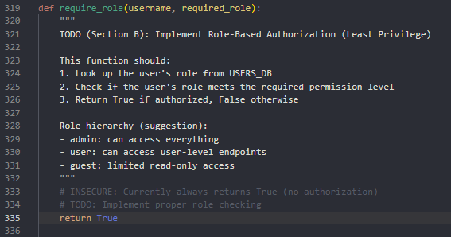

B2)
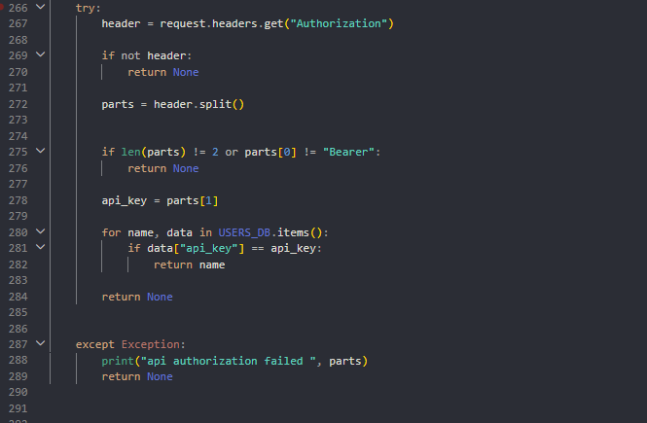
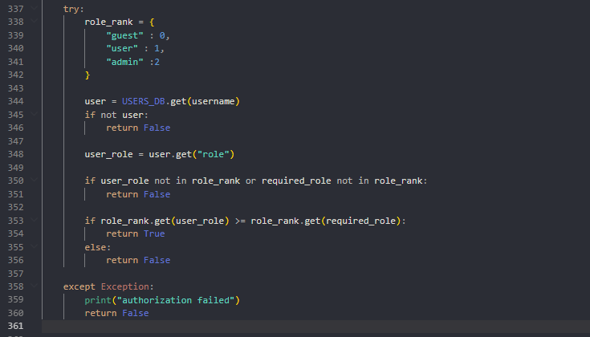

B3)

C1)
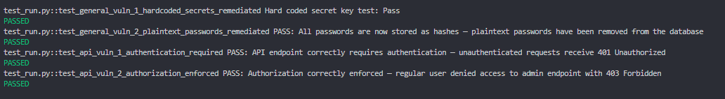
C2)
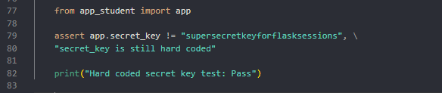
C3)
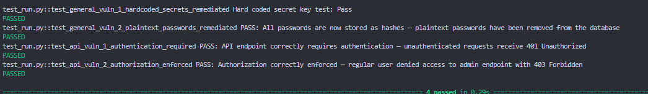
C4)

C5)

D1)
Mitigation Strategy #1) The first mitigation strategy that is implemented is not hard coding the secret key in the source code but rather getting it from the environment variable. By getting the secret key from the environment, developers protect the secret from anyone with access to the source code. This is important because it reduces the chances of bad actors getting a hold of the secret key.
Mitigation Strategy #2) The second mitigation strategy is hashing the password from USER_DB. By adding a hash function to the password, developers protect the password in its plaintext. This allows users to be protected if bad actors can get into the system. They would only be able to view the password as a hash rather than the password in its plaintext.
D2)
Input Validation #1) The first input validation is the require_api_key() validation. First, the validation makes sure that the input is in the right format which is Bearer API_KEY. After that it checks whether the API KEY is a working key when checking the header authorization up against the USER_DB. If the api key can be found within the USER_DB then return the user’s name. This makes sure that the api matches the user. By utilizing this function, users can have access to the API if the keys match. This function is used in the @app.route('/api/v1/rentals', methods=['GET']). This makes sure the person is who they say they are being giving back information which is important aspect of security.
Input Validation #2) The second input validation is the def require_role(username, required_role) validation. This checks whether the users are authorized to view a page. The function defines a ranking system based on role and compares it with the required role. If the user’s role is equal to or higher than the required role the user has access to the info. This function is used and implemented in @app.route('/api/v1/admin/users', methods=['GET']). Since this route is for admin’s view only, the current user role must be admin. If the user’s role is not admin then they would be met with a 403 error since the page is only for admin. This is important because it filters out who can view what pages base on role which is another important aspect of security.

D3)
Exception #1) The first exception handling is found in the def require_api_key() function with try and except blocks. By utilizing this exception, developers are notified when the def require_api_key() function failed after doing everything in the try block and return. This helps developers pinpoint where the function breaks if it does. This enhances security because it allows developers to fix problems as they show up, which also increases the reliability of the function.
Exception #2) The second exception handling is found in def require_role(username, required_role). Like the first example, this exception also makes sure whether the function is operating correctly. By utilizing this tool, developers can find out why the code breaks if the code breaks after trying everything in the try block. This allows developers to see if any other inputs or value might make that code break and if it does, they can fix it. This is important to reliability and security because if that input causes the code to break but was not part of the exception handling then it would just pass by unnoticed leading to vulnerabilities.
D4) One method of encryption that is used is TLS when transferring data between server and client. When transferring data such as api keys, login username and password, json, etc the data is automatically encrypted so that bad actors who have access to the network traffic can’t view the data since it’s encrypted. This is important in security because it protects the data from being understood if the data does get compromised.

